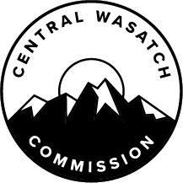
Short-Term Projects
2024-2025 Grant Cycle
Project Idea Worksheet

Please complete this worksheet and the questions found at the bottom of this page and send to Sam Kilpack at samantha@cwc.utah.gov no later than March 25, 2024.
For project criteria, visit cwc.utah.gov.
Name of the project:
Location of the project:
Project contact person:
Project contact email address:
Project category (select any that apply) | ☐ Transportation and transit  ☐ Environmental protection  ☐ Recreation stewardship  ☐ Economic sustainability
Do you have community partners for this project? Please list your partners, if applicable:
What is the estimated total cost of the project? How much will you request from the CWC?
What is the expected starting date and completion date for the project?

Please attach your answers to the following questions:
- Briefly describe your idea. How will it implement transportation and transit solutions, protect the ecosystems that originate in the Central Wasatch, steward recreational access, or sustain the economic viability of the project area?
- Does this idea result in other benefits to the Central Wasatch and its users?

